Query : **14.139.211.151**

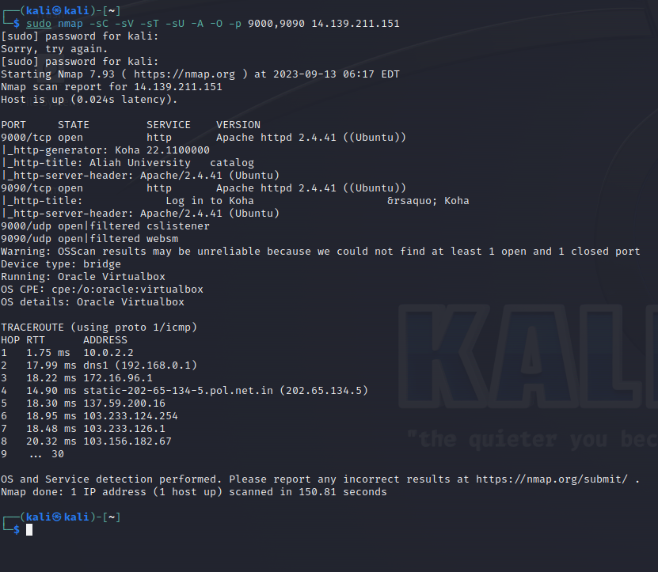

OS detection of <http://14.139.211.151:9000/>

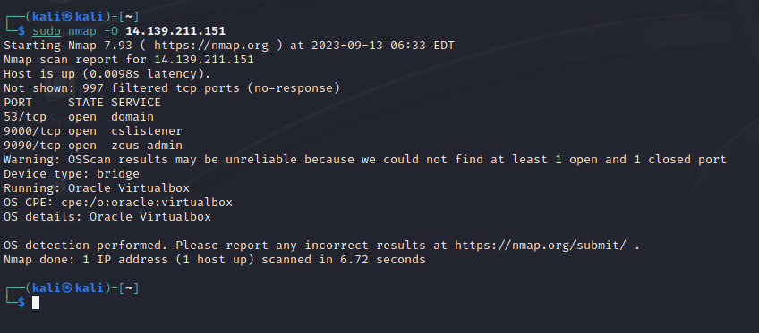

Version details of <http://14.139.211.151:9000/>

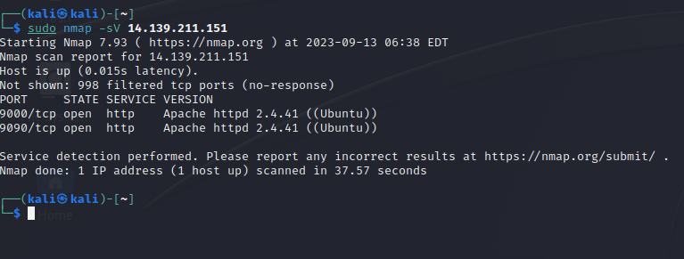

Aggressive scanning <http://14.139.211.151:9000/>

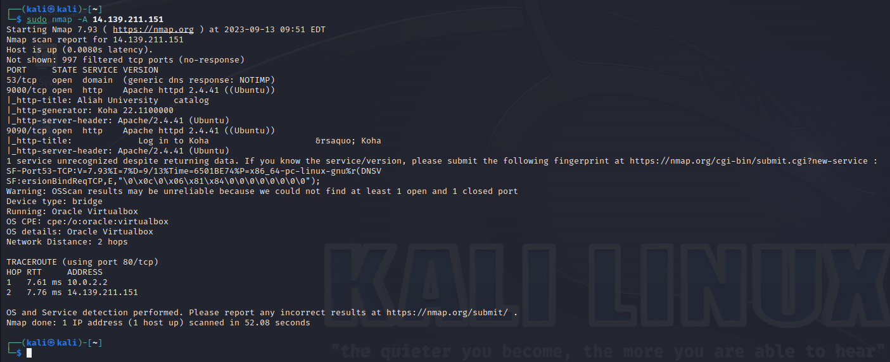

QUERY.2 **68.178.170.134**

OS detection of [http://68.178.170.134](http://68.178.170.134/)

.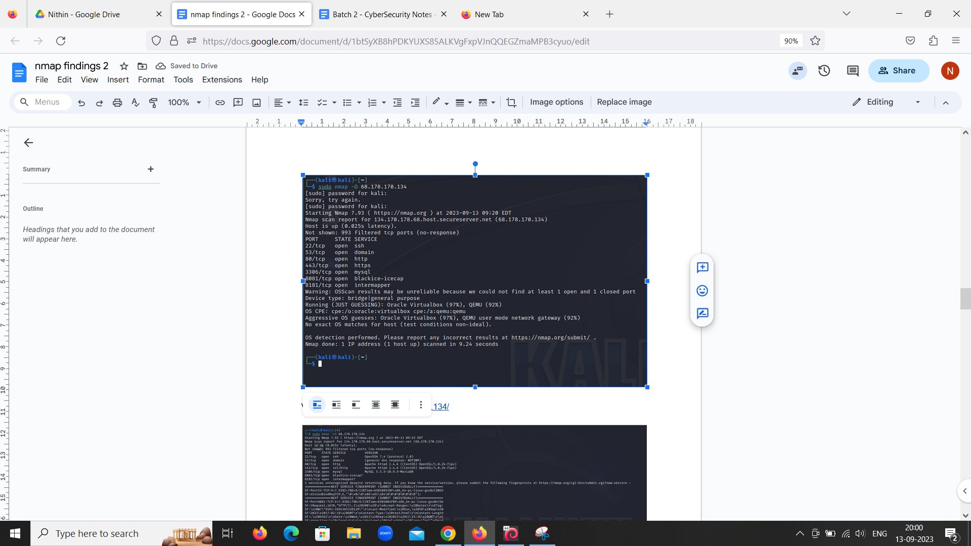

Version details of <http://68.178.170.134/>

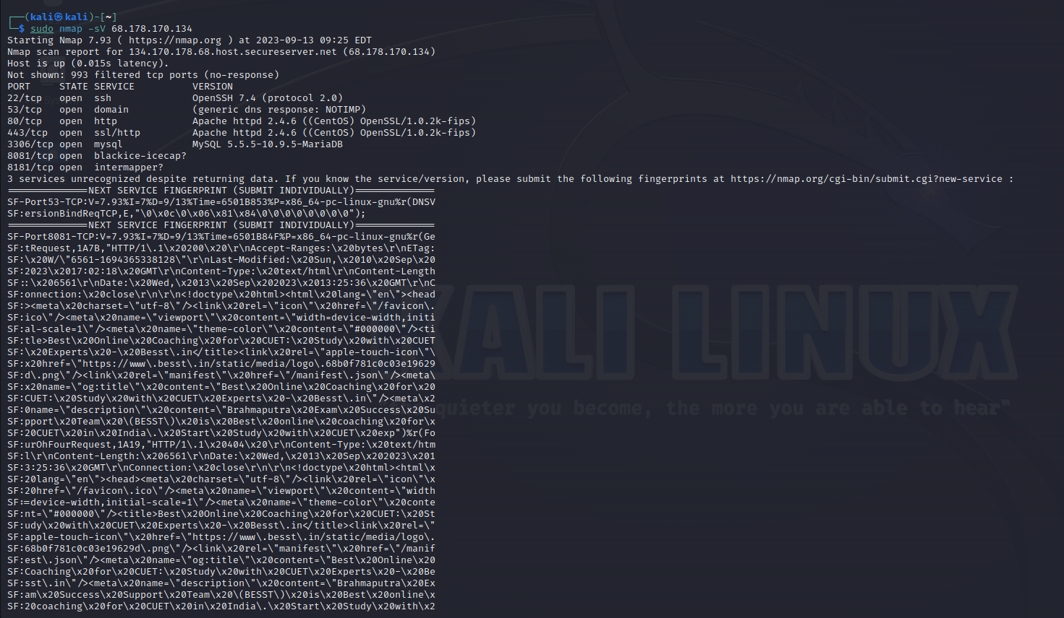

Aggressive scanning [http://68.178.170.134](http://68.178.170.134/)

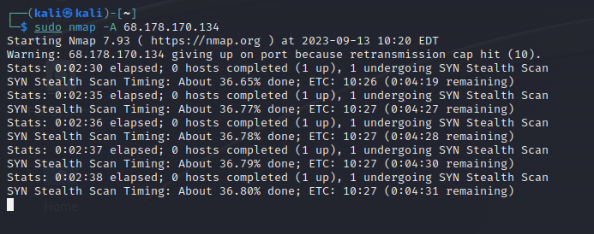

Query . 3 **68.178.169.27**

OS detection : :<http://68.178.169.27/>

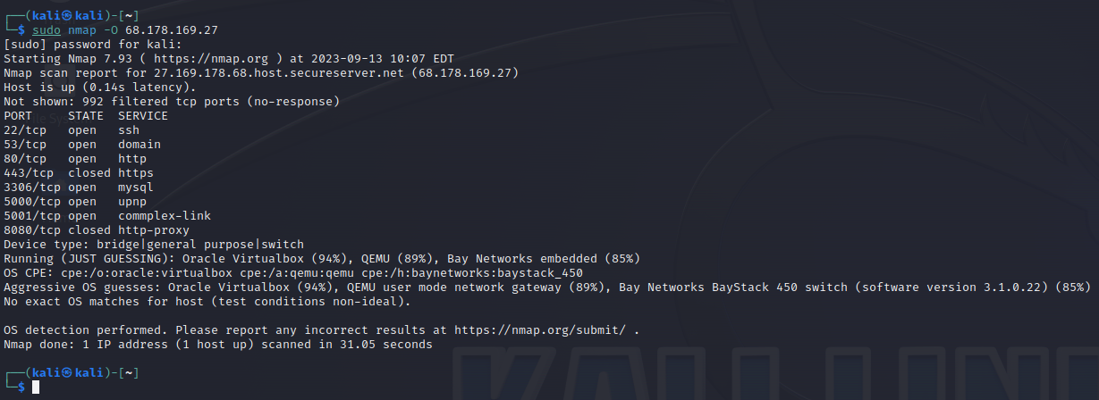

Version details of : <http://68.178.169.27/>

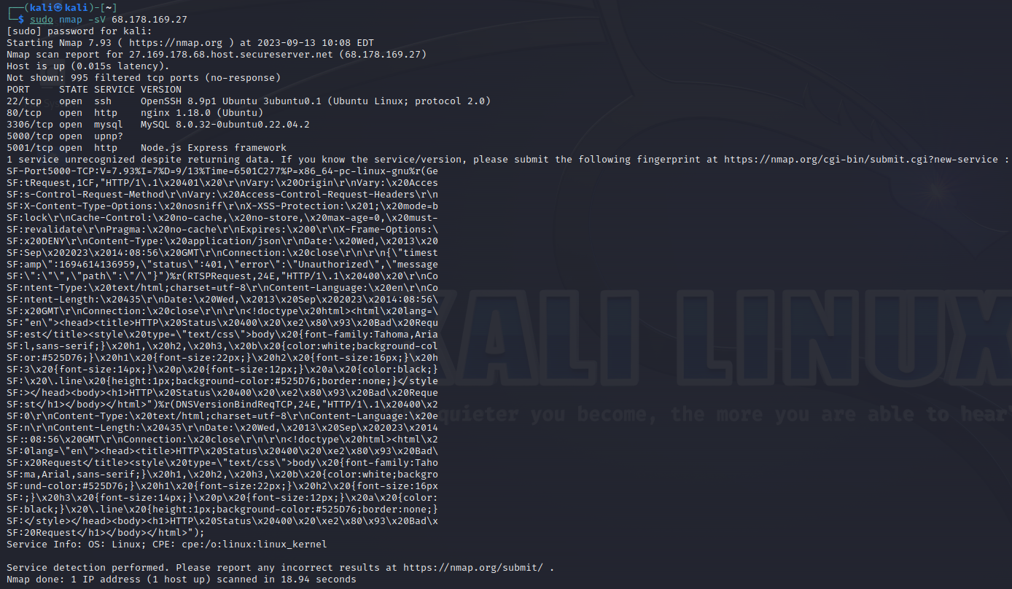

Aggressive scanning : <http://68.178.169.27/>

